Exercise A – A Steady State Heat Conduction

In this exercise you are going to measure the temperature distribution for steady-state conduction of
energy through a uniform cylindrical wall (radial) and demonstrate the effect of a change in heat flow.

Procedure
1. Start your experiment only after you receive operating and safety practice by your instructor!
2. Insure that water is supplied to the cold section.
3. Insure that the flexible water connection is directed to the drain.
4. Insure that each thermocouple is connected to its socket at part (K) of the service unit.
5. Insure that switch (B) on the service unit is toward the Manual setting.
6. Insure that you select V on the measurement selection switch (E).
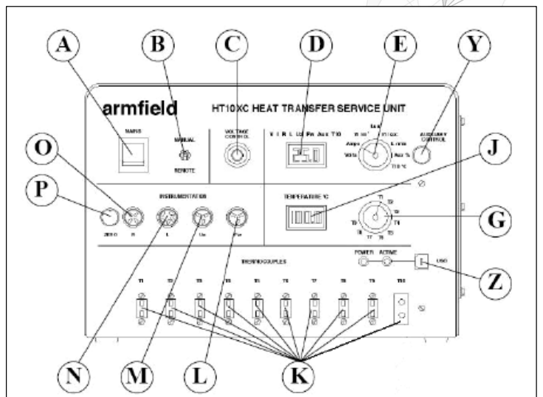

Figure2: HT10XC Service Unit
7. Turn on the main standby switch (A)
8. Watch the voltage readings on top panel meter (D) (since you selected V on step number 6).
9. Starting from zero voltage increase the volt gradually to 12V.
10. At 13V change the measurement selection switch (E) to I, and read the corresponding current value on meter (D).
11. Make sure that the temperature switch (G) is located at T1, as a start, you will change it later.
12. Wait for 10min (for a steady-state condition) and watch the temperature on the adjacent panel meter (J).
13. After reaching a steady state, take the reading of T1 and change the temperature reading switch to display other temperatures.
14. Fill the table below of the temperatures at different layers and don’t forget to mention the
units.
Note that at the third layer you won’t be able to measure T3, this will be calculated later.
15. Repeat step 9 with changing the voltage at 14 and 16V.

4-Results and Discussion

Table 1: Temperatures recorded for each thermocouple vs position along the bar

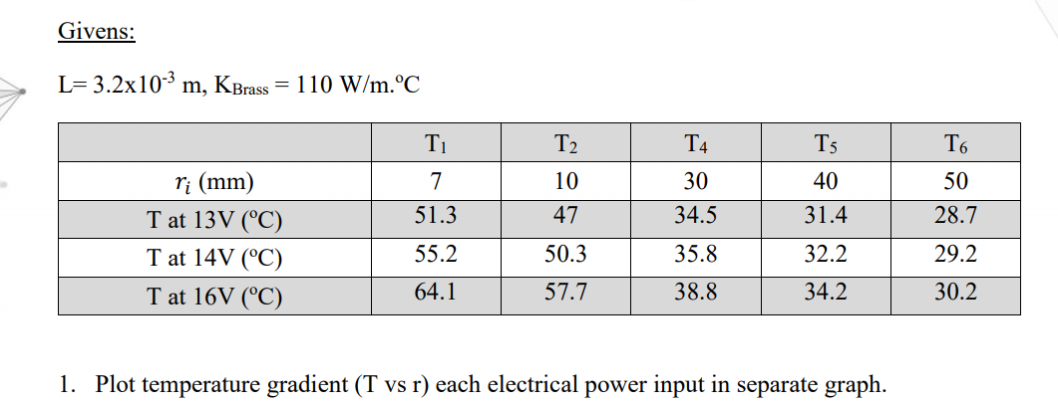

Graph A
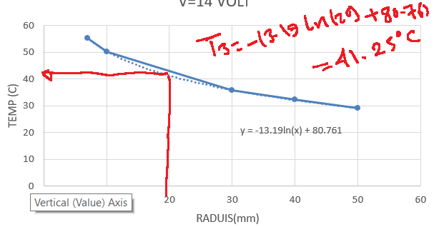

Graph B
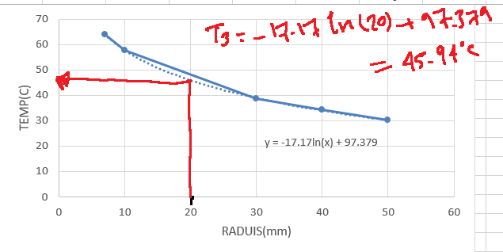

The above graphs A and B show the gradual change in temperature relative to the radius of thermocouple subjected to a current of 14V and 16V respectively. The temperatures gradually decline with the increase in radius of the thermocouple. This evidently shows an increase of thermal resistance to conductivity relative to the radius of the thermocouple.

Note: As shown in graph A, given the radius of a thermocouple (T3) as 20mm an output temperature of 41.25 degree ℃ was recorded when an electric power input of 14V was initiated. With an electric power input of 16V, given a similar radius of 20mm, a thermocouple (T3) recorded an output of 45.94 ℃, this is shown in graph B.

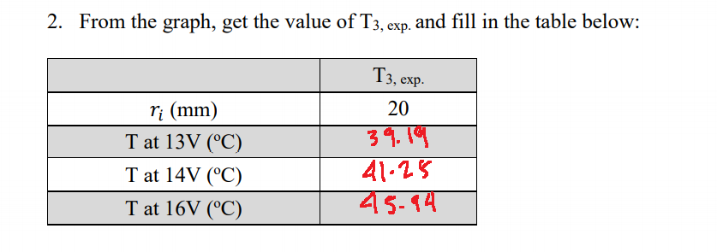

5,Sources of Error
1 Error Sources associated with Loss of Steady-State Conditions The problem of deviation from steady-state conditions is entirely instrument related. The specific error sources are temperature variation and non-linear heat flow
2 Error Sources associated with Q/A
HFM instruments measure Q/A using thin heat flux sensors, one embedded in each instrument platen. The heat flux sensor designs for this particular instrument are proprietary, making it difficult to comment in detail.
3 Error Sources associated with ∆x ∆x is the one source of error that is entirely specimen related, and thus entirely within the control of the operator. Obtaining an average ∆x value for a given specimen is straightforward enough; the problem is the standard deviation around that average. The various sources of error, whether macroscopic (lack of planarity, in the form of undulations or hollows, or lack of parallelism) or microscopic (lack of smoothness) can be gathered together under a single heading: specimen preparation tolerance
. 4 Error Sources associated with ∆T There are a number of error sources associated with the measurement of ∆T, all of them basically related to the Type E thermocouples used by the instrument under discussion to measure T1 and T2 (∆T = T1 – T2).

